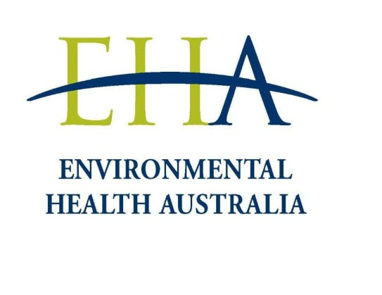
ENVIRONMENTAL HEALTH AUSTRALIA (Limited)
Margaret Hind Memorial Award 2019

NOMINATION FORM

The Undersigned hereby submit the below nomination for consideration for the
2019 Margaret Hind Memorial Award.

Details of Nominee

Name

Position

Organisation

Postal Address

Telephone

E-Mail

Grade of EHA Membership | Associate Member Member Fellow
Past Employers | 1.
 | 2.
 | 3.

Details of Referees

Name

Position

Organisation

Postal Address

Telephone

E-Mail

Name

Position

Organisation

Postal Address

Telephone

E-Mail

Details of Nominating Person

Please Note: If as for Details of Nominee only ‘Name’, ‘Signature’, ‘Date’ and ‘Grade of EHA Membership’ fields require completion.

Name

Signature |  | Date
Position

Organisation

Postal Address

Telephone

E-Mail

Grade of EHA Membership | Associate Member Member Fellow

Please send completed NOMINATION FORM and SUPPORTING STATEMENT to

The Executive Officer
EHA Ltd
PO Box 2222
FORTITUDE VALLEY QLD 4006

Email: national@eh.org.au

Nominations close to 2 September 2019.

The selection committee may not consider nominations received after this date.

